Send Redirection makes source servlet comp talking to dest web comp after having one network round trip with browser. Since browser can give request to any technology and location web comp, so we can place the dest web comp in send Redirection process in any location and in any web technology.

Use Cases:

=======

1. To use external website services being from current website with out worrying about external website technology and location.

Ex:: Local website using google search box.

Local website using google maps.

Flipkart using payment gateway app.

1. If company A acquires company B .. then the requests given to B.com will be redirected to A.com website

Ex:: 1sun MS is acquired by Oracle corp, so the request given to sun.com will be redirected to page of oracle.com.

EX:: rational company is acquired by IBM , so the request given to rational.com goes to IBM.com webpage.

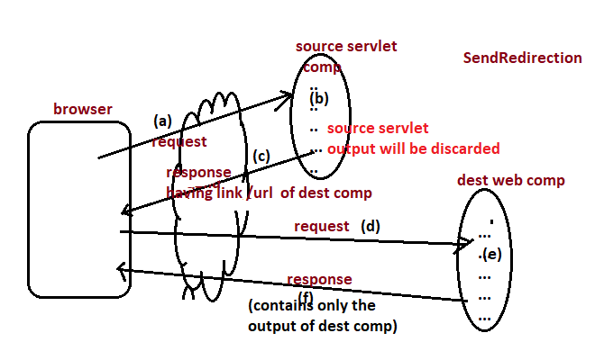

Send Redirection can be done in two ways:

1. Using HyperLinks
2. Using sendRedirect(-)method of response (The Best).

1.Using HyperLinks:

===============

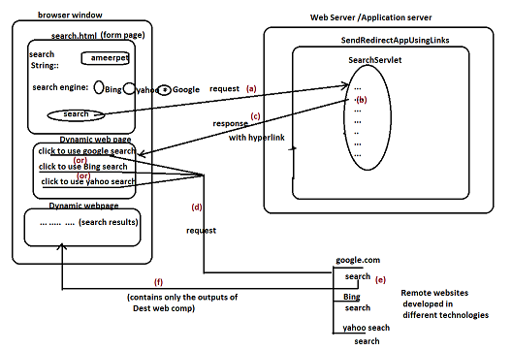

Limitation of send-Redirection using Hyperlinks: If the end user forgets to click on the hyperlink the sendRedirection fails.

Example:-

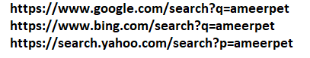

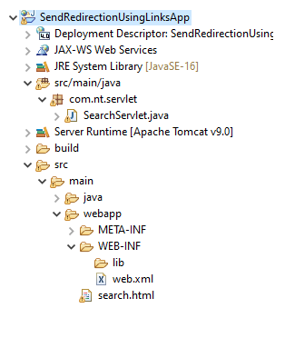

Search.html

=========

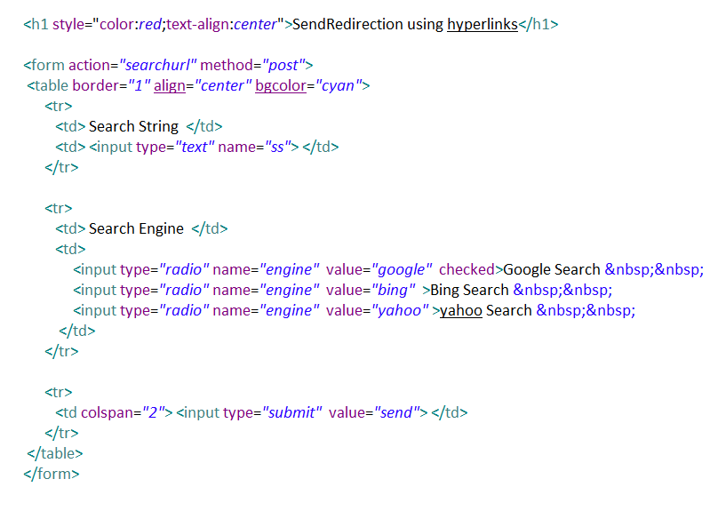

SearchServlet.java

===============

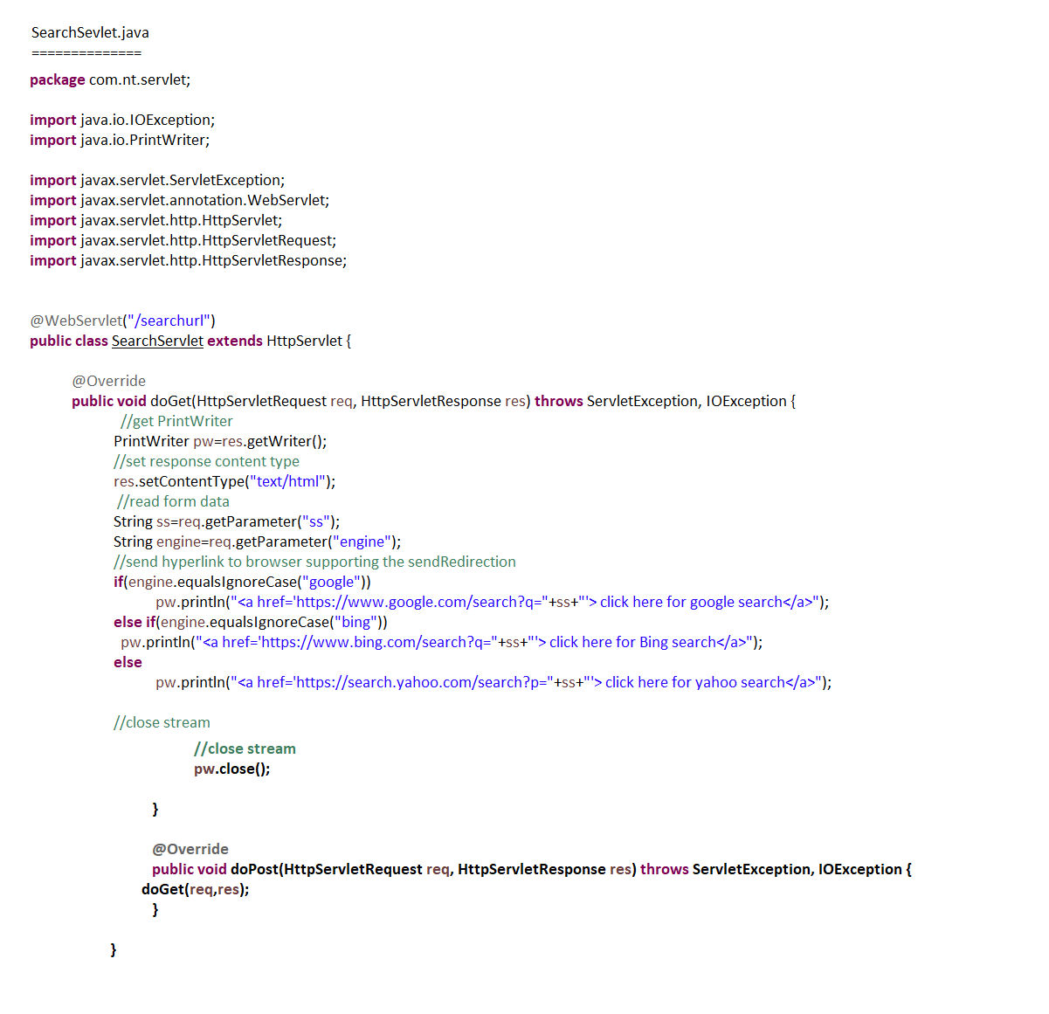

Web.xml

=======

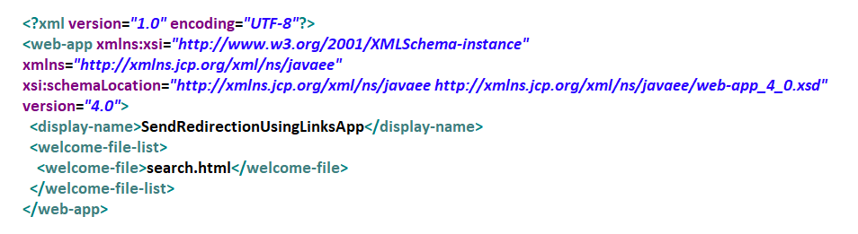

2. Using Send Redirection Method:-

=========================

1. Res.sendRedirect(-) performs sendRedirection mode servlet communication.
2. All the statements placed in source servlet comp executes and their generated output will be discarded because of res.sendRedirect(-) method execution.
3. The source servlet comp and dest comp will not be using same request,response objects So the request data coming to source servlet comp is not visible and accessible in the dest comp.
4. To pass data from source servlet comp to dest comp place query string to url of res.sendRedirect(-) method. And use req.getParameter(-) methods to read them in Dest comp.
5. The source servlet comp talks with dest web comp after having network round trip with browser.
6. Here, no need of clicking any hyperlinks to complete the send redirection.

Example:

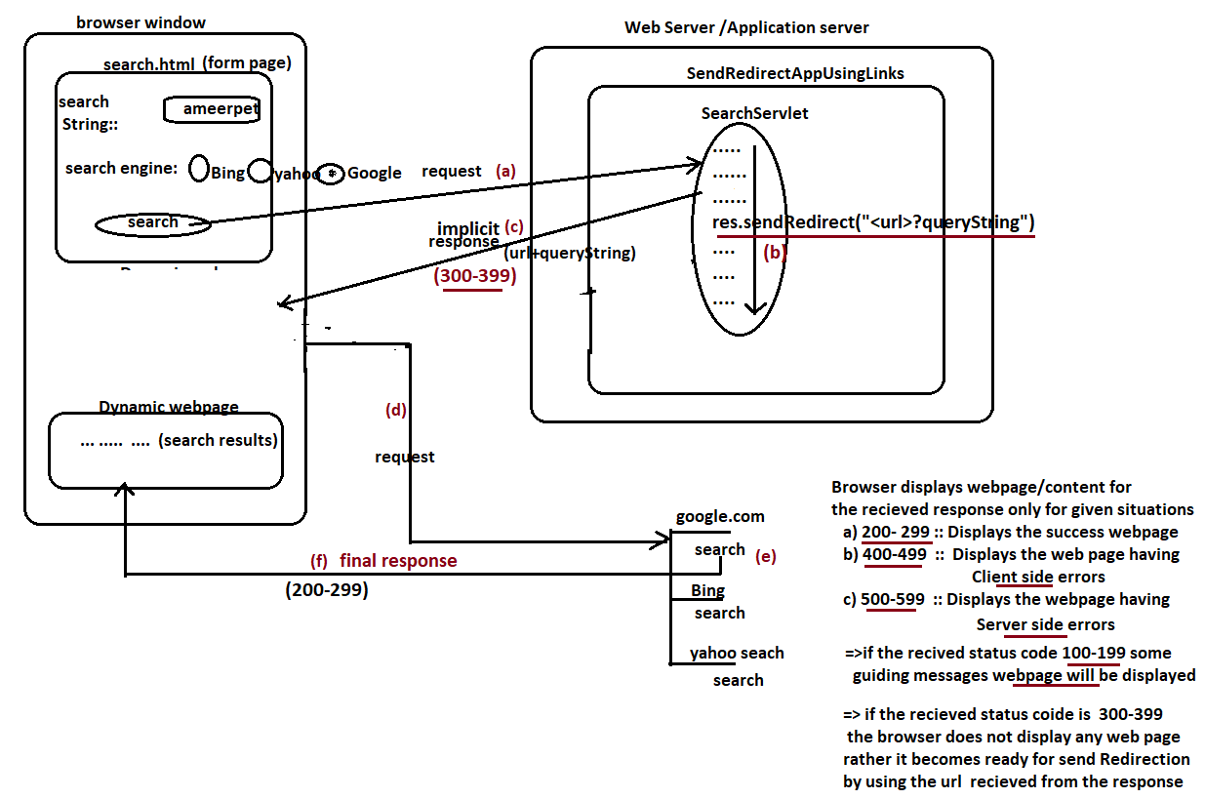

Example:

=======

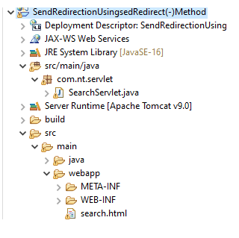

Search.html

==========

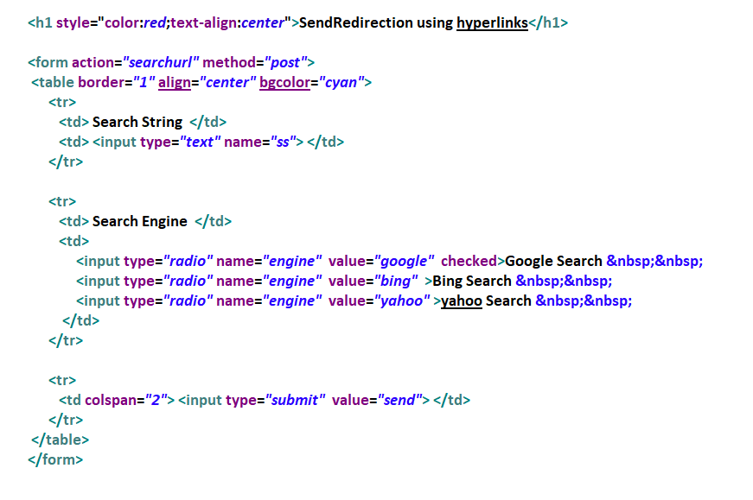

SearchServlet.java

================

